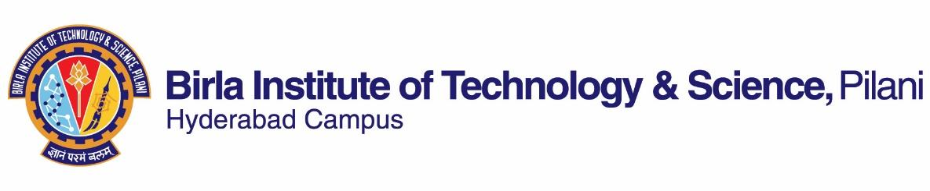

**FIRST SEMESTER 2022-2023**

**Course Handout (Part II)**

**29.08.2022**

In addition to part I (general handout for all courses appended to the timetable) this portion gives further specific details regarding the course.

**Course No : BIO F312**

**Course Title : PLANT PHYSIOLOGY**

**Instructor-In-Charge : SRIDEV MOHAPATRA**

**Instructor : Gireesha T. Mohannath, Raja Gopalan NS**

**1. Course Description:**

Basic functional processes in plants; plant tissue system, plant-water relations, gaseous exchange, stomatal regulations, mineral nutrition and absorption, transport of material, growth and development, hormones and plant growth regulators, photoperiodism, vernalization, plant defense mechanisms, stress physiology.

**2. Scope & Objective:**

This course attempts to bring the awareness to the students of major features of physiology of plants. Emphasis will be given to function and adaptations as related to the survival of plants in their natural environment.

**3. Text Book and Reference Book:**

**Text book (T1):** Taiz, L., Zeiger, E., Møller, I.M., Murphy, A. Plant Physiology and Development, 6th Ed., 2015, Sinauer Associates, Inc. Sunderland, Massachusetts, U.S.A.

**Reference book (R1):**

Taiz, L. and Zeiger, E., Plant Physiology, 5th Ed., 2010, Sinauer Associate Inc., Sunderland, Massachusetts, U.S.A.

**Web Reference:** <http://6e.plantphys.net/>

**4. Course plan:**

|  |  |  |  |
| --- | --- | --- | --- |
| **Lect. No.** | **Learning objective** | **Topics to be covered** | **Chapter in the Text Book** |
| 1 | Getting introduced to the subject and course | Orientation to the course, Introduction to Plant Physiology | Class Notes |
| 2-3 | Overview of Plant Structure | Plant Tissue System | Class Notes |
| 4-5 | Learning about water and its interaction with plant body | Structure and properties of water, Diffusion, Osmosis and Water potential | TB-3, RB-3 |
| 6-7 | How do plants obtain water from soil? | Water balance in plants: root absorption and transport through xylem | TB-4, RB-4 |
| 8-9 | Stomatal regulations | Transpiration and its compromise with photosynthesis | TB-4, 10, RB-4 |
| 10-11 | Mineral requirement for plant growth | Mineral Nutrition: Essential elements and their function | TB-5, RB-5 |
| 12 | How nutrients are absorbed and distributed in tissues? | Mineral Nutrition: Absorption of minerals, Mycorrhizal fungi | TB-5, RB-5 |
| 13-15 | Transport of solutes and ions, Membrane transport processes | TB-6, RB-6 |
| 16-18 | How are metabolic end products distributed in plants? | Transport of material in phloem | TB-11, RB-11 |
| 19-21 | How plants grow? | Growth and development | TB-17, 18 (Pg 514,-520)19 (Pg 553-559), RB-16, |
| 22-27 | What controls plant growth? | Hormones and Growth regulators: Auxins and Gibberellins | TB-15 (414-417, 421-422, 437-441), 18 (522-533)  RB-19, 20 |
| 28-31 | Cytokinins, Abscisic acid | TB-15 (Pg 418-419, 423-428, 431-437)  RB-21, 23 |
| 32-33 | How do plants respond to light? | Phytochrome-mediated red light responses | TB-16 (Pg 447-461), 18  (Pg 537-541) RB-17, 25 |
| 34-35 | Photoperiodism and Flowering | TB-20, RB-17, 24 |
| 36-37 | How do plants defend themselves against adverse biotic factors? | Secondary metabolites and Plant Defense Mechanisms | TB-23, RB-13 |
| 38-40 | How do plants defend themselves against adverse abiotic factors? | Stress physiology: Water, Heat, Chilling & Salinity stress | TB-24, RB-25 |

**5. Evaluation scheme:**

|  |  |  |  |  |
| --- | --- | --- | --- | --- |
| Component | **Duration** | **Weightage %** | **Date & Time** | **Nature of the Component** |
| Mid-sem exam | 90 min | 30 | 03/11  1.30 - 3.00 PM | CB |
| Tutorial tests (multiple) | Variable | 15 |  | CB |
| Assignments (2) | Variable | 20 |  | OB |
| Comprehensive | 180 min | 35 | 26/12 AN | OB |

**6. Grading Policy:**

Award of grades would be guided by the histogram of marks. Decision for cases on borderline of two grades will be based on the student’s promptness and participation in classroom activities as well as satisfactory attendance in lecture and tutorial classes. If a student misses even a single component entirely or does not give sufficient opportunity for being assessed, he/she may be awarded ‘NC’ report regardless of his/her final total score in the course (see Clause 4.19 of *BITS Academic Regulations*).

**7. Office Consultation:**

Will be announced in class.

**8. Make-up Policy:**

Only medical emergencies with evidence will be considered for make-up for tests and comprehensive examination. For regulations about the make-up flexibility, students are advised to refer to Clause 4.07 of *BITS Academic Regulations*

**9. Course Announcements and Notices**:

Announcements pertaining to the course will be made in the lecture/tutorial class and/or on CMS.

**10. Academic Honesty and Integrity Policy**: Academic honesty and integrity are to be maintained by all the students throughout the semester and no type of academic dishonesty is acceptable.

**INSTRUCTOR-IN-CHARGE**

**BIO F312**